Computer Language Coding Concepts

Clause in a Diagram
The principle of clauses is explained in the article Clause. This article demonstrates its expression in a diagram.

A clause is a command, defined within a command.

An active clause is shown in a diagram as a diamond placed inside a command symbol:



An inactive clause is shown in a diagram as a square inside a command symbol.



A clause can just as well be placed inside a diamond, instead of a square:

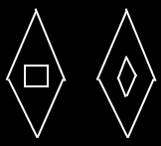

A clause will never redirect its definition or object to another command.

See also: Clause

Author & Copyright: Jan-Joost van Zon Date: May 25, 2008 – August 12, 2008 Location: Oosterhout, The Netherlands Status: Finished

